ASSIGNMENT
Assignment: Encoding Character Sets

Name: Qandeel Asim
Roll Number: BS AI 037
Program: BS Artificial Intelligence
Subject: Information Security

Topics: UTF-8, UTF-16, ASCII and Unicode

1. Introduction to Character Encoding
Character encoding is basically a way of telling a computer how text should be stored and understood. A computer works with binary data, so letters, numbers and symbols have to be converted into numerical values. For example, the letter A has a fixed value in ASCII. But if we want to use Urdu, Arabic, Chinese or emojis, we need a character system that can handle many more characters.
In this assignment, I have discussed four important terms: ASCII, Unicode, UTF-8 and UTF-16. ASCII is an older standard and is mainly useful for English characters. Unicode was developed to provide characters for many different languages. UTF-8 and UTF-16 are two ways of encoding Unicode characters so that computers can store and transfer them.
Correct encoding is important because if the wrong encoding is used, the text may appear as strange symbols or question marks. This is also important in information security because systems often deal with usernames, messages, files, websites and logs. If text is not handled correctly, data can be changed or misunderstood.

2. UTF-8
UTF-8 stands for Unicode Transformation Format – 8-bit. It is a variable-length encoding used to represent Unicode characters. It can represent characters from almost every modern writing system and is the most widely used Unicode encoding on the web. UTF-8 uses between one and four bytes for a Unicode character. Common English characters use one byte, while many other characters use two, three or four bytes.

Working
UTF-8 first checks the Unicode code point of a character and then converts it into one, two, three or four bytes according to its range. Characters in the basic ASCII range use exactly one byte and keep the same values as ASCII. For example, the character 'A' is represented by the byte value 65 (hexadecimal 41). A non-ASCII character requires additional bytes. The receiving system reads the byte pattern and reconstructs the original Unicode character. This variable-length design saves space for ordinary English text while still supporting international text.

Advantages
- It supports a very large range of Unicode characters.
- ASCII characters remain compatible with UTF-8.
- It is efficient for English and many text-processing tasks.
- It is the dominant encoding for web pages, APIs and many text files.
- It does not require a byte-order mark (BOM) for normal use.
- It works well when data contains multiple languages.

Disadvantages
- Characters outside the ASCII range can require more than one byte.
- Character boundaries are not always one byte apart, so processing individual characters can require more care.
- Poorly declared encoding can still produce corrupted text.
- Some older systems or applications may not handle Unicode correctly.

Examples / Uses
- HTML and web pages
- JSON and XML data
- Email and text files
- Databases and application programming
- Urdu, Arabic, Chinese and other multilingual content
- Modern software source code

Importance in Information Security
Security-related systems often process text from users, files, web requests and databases. UTF-8 provides a consistent way to represent multilingual input. However, security-sensitive applications should normalize and validate text appropriately because visually similar characters and different Unicode representations can sometimes create confusion in usernames, URLs or identifiers.

Conclusion
UTF-8 is flexible, compact for ASCII-based text and highly suitable for multilingual applications. Its compatibility with ASCII and broad Unicode support make it a practical encoding choice for modern systems.

3. UTF-16
UTF-16 stands for Unicode Transformation Format – 16-bit. It is another Unicode encoding format. It normally represents a character using one 16-bit code unit, but characters outside the Basic Multilingual Plane can require two 16-bit code units called a surrogate pair. Therefore, UTF-16 is also a variable-length encoding at the character level.

Working
UTF-16 takes a Unicode code point and represents it using 16-bit units. Most common characters are stored in one 16-bit unit. For characters with higher code points, UTF-16 uses two special 16-bit units called a high surrogate and a low surrogate. When these two units are read together, they identify the original Unicode character. UTF-16 can be stored in little-endian or big-endian byte order, and a BOM may be used to indicate the byte order.

Advantages
- It can represent the full Unicode character set.
- Many common non-ASCII characters can be represented in one 16-bit code unit.
- It is useful in systems and software environments that internally use 16-bit units.
- It provides direct support for Unicode text.
- It is used by several programming environments and file formats.

Disadvantages
- For mostly English text, UTF-16 usually uses more storage than UTF-8.
- Some characters require surrogate pairs, so one character is not always one 16-bit unit.
- Byte order may need to be specified or detected.
- It is less common than UTF-8 for general web content.

Examples / Uses
- Windows and some Microsoft technologies
- Java's internal character representation historically based on 16-bit char units
- Some APIs and software libraries
- Unicode text processing
- Applications requiring compatibility with UTF-16-based interfaces

Importance in Information Security
Security applications should correctly interpret UTF-16 data before validation or logging. Problems can occur if one system assumes UTF-8 while another system sends UTF-16. Consistent encoding declarations and safe conversion between encodings help avoid data corruption and input-processing mistakes.

Conclusion
UTF-16 is a useful Unicode encoding, especially in environments designed around 16-bit code units. It provides broad Unicode support but may use more storage than UTF-8 for English-heavy data.

4. ASCII
ASCII stands for American Standard Code for Information Interchange. It is one of the earliest widely used character encoding standards. Standard ASCII uses 7 bits and defines 128 characters, including English letters, digits, punctuation marks and control characters. Examples include A–Z, a–z, 0–9 and symbols such as !, @ and #.

Working
ASCII assigns a numerical value to each defined character. For example, uppercase A has decimal value 65, lowercase a has value 97, and digit 0 has value 48. These numerical values are stored as binary data. Standard ASCII uses seven bits, although an 8-bit byte is normally used to store each ASCII character in modern systems. The first 32 values are mainly control characters, while printable characters occupy the remaining standard range.

Advantages
- Simple and easy to understand.
- Requires little storage for its limited character set.
- Very widely supported by old and modern systems.
- Useful for English letters, digits and common symbols.
- UTF-8 preserves ASCII compatibility for the first 128 values.

Disadvantages
- Standard ASCII cannot represent Urdu, Arabic, Chinese and many other languages.
- It has only 128 standard characters.
- It cannot directly represent modern emojis.
- Extended 8-bit character sets are not the same as standard ASCII and can vary between systems.

Examples / Uses
- Programming source code
- Plain English text
- Control characters in communication protocols
- Older computer systems
- Command-line data and simple text formats

Importance in Information Security
ASCII is predictable and simple, which can be useful when a protocol expects a restricted set of characters. Security-sensitive systems should define exactly which characters are accepted rather than assuming that all 8-bit values have the same meaning across systems.

Conclusion
ASCII is historically important and remains useful for basic English text and protocols. Its major limitation is its small character set, which is why Unicode and Unicode encodings are used for modern multilingual text.

5. Unicode
Unicode is a universal character standard designed to give characters from different writing systems unique code points. It is not simply one byte-based encoding. Instead, Unicode defines a common character repertoire and assigns code points to characters. Encoding formats such as UTF-8 and UTF-16 are used to store or transmit those Unicode code points.

Working
Each Unicode character is assigned a code point, commonly written in the form U+ followed by hexadecimal digits. For example, the Latin capital letter A is U+0041. Unicode contains characters and symbols from many scripts, including Latin, Arabic, Urdu, Chinese and many others, as well as mathematical symbols and emoji. An encoding such as UTF-8 then converts the Unicode code point into bytes for storage or transmission.

Advantages
- Supports text from many languages in one standard.
- Provides a common code-point system across different platforms.
- Supports modern symbols and emoji.
- Works with multiple encoding formats such as UTF-8 and UTF-16.
- Reduces the need for separate character standards for different languages.

Disadvantages
- Unicode itself does not specify one single byte representation for storage; an encoding must be chosen.
- Unicode processing can be more complex than simple ASCII processing.
- Different visual forms can sometimes look similar even when their code points differ.
- Applications still need correct normalization, validation and font support.

Examples / Uses
- International websites
- Mobile applications
- Multilingual databases
- Messaging applications
- Operating systems and software
- Urdu and Arabic text processing
- Emoji and special symbols

Importance in Information Security
Unicode is especially important for secure international applications because user input can come from many languages. Applications should use consistent encoding, validation and normalization rules. Security teams also need to be aware of look-alike characters and unexpected Unicode forms when handling usernames, domains and identifiers.

Conclusion
Unicode provides the foundation for modern multilingual text processing. UTF-8 and UTF-16 are examples of ways to encode Unicode characters. Together, Unicode and its encodings allow computers to exchange text reliably across languages and platforms.

CAPTURING FROM WIFI:
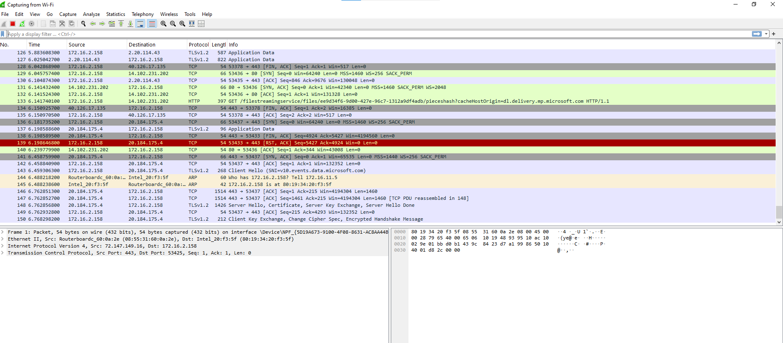

TCP.STREAM EQ69
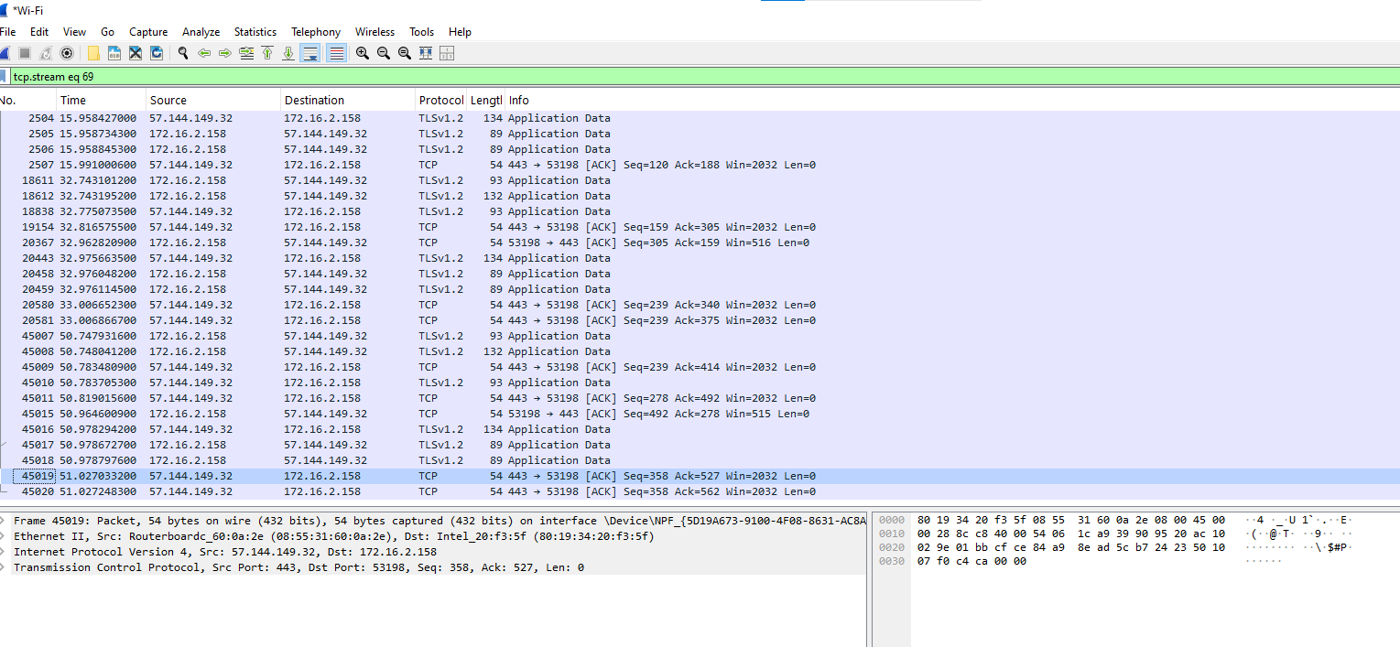

HTTP.REQUEST
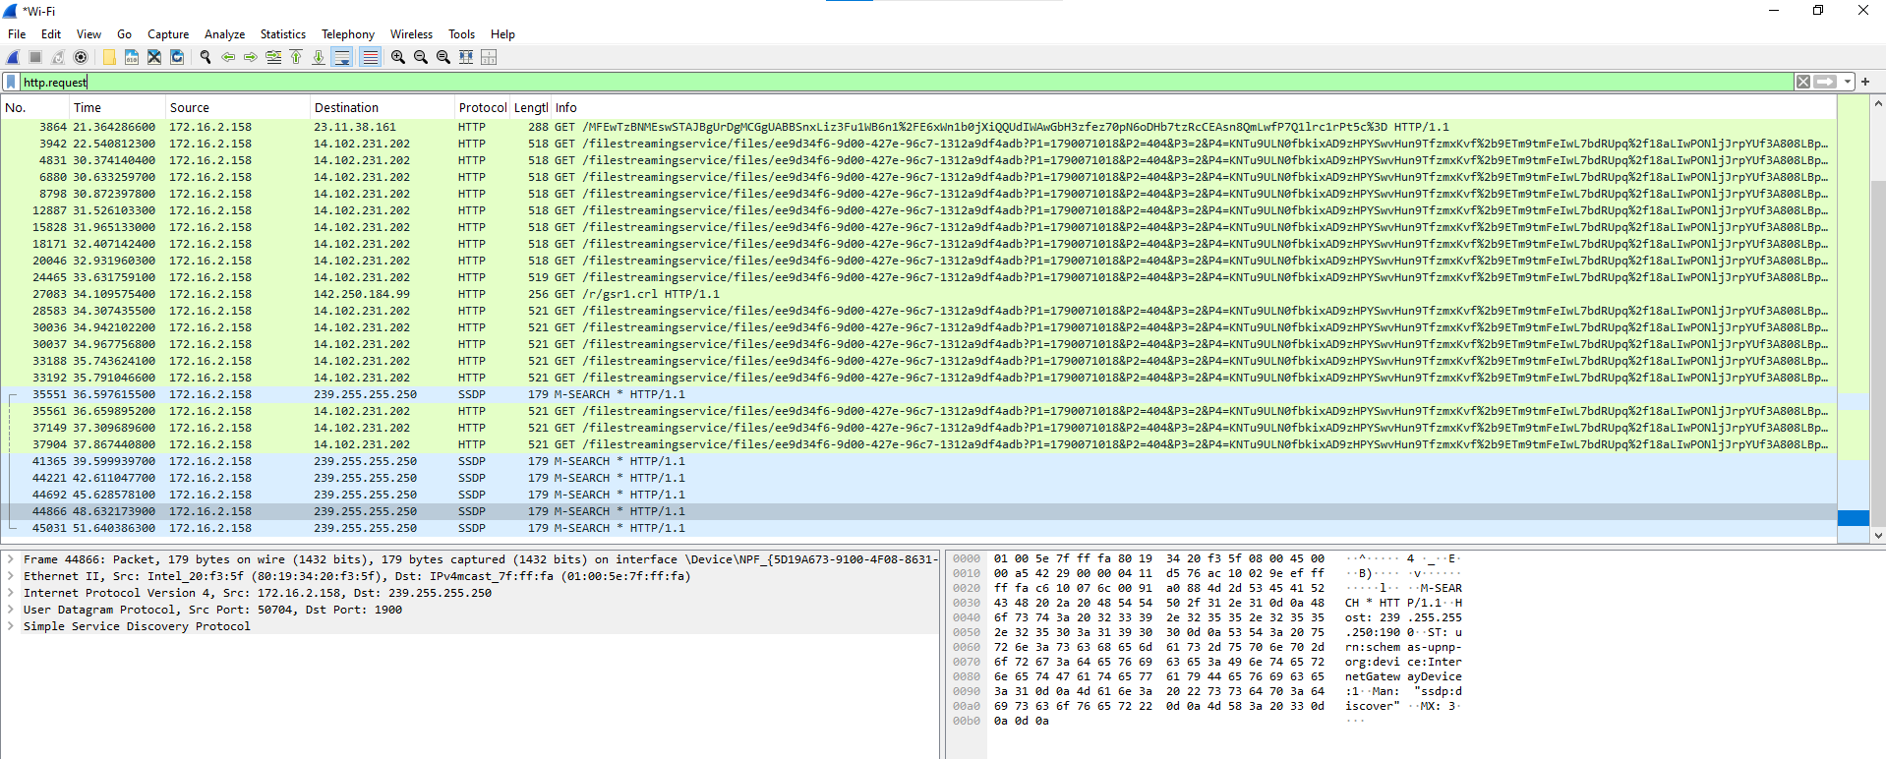

COLOURING RULES
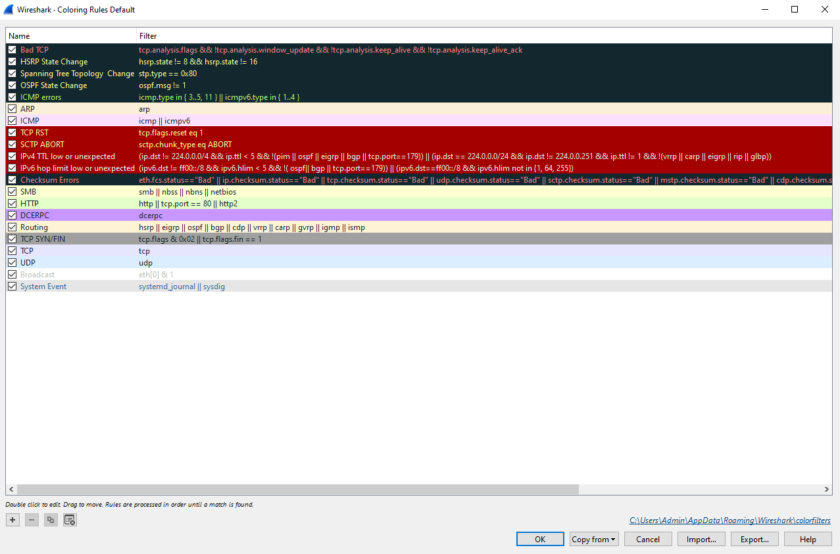

HTTP.RESPONSE.CODE ==404
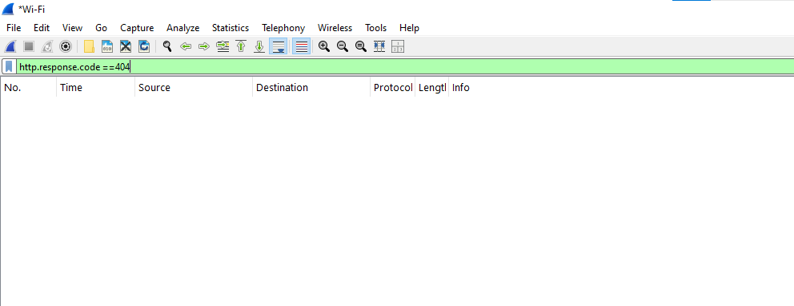

HTTP.RESPONSE.CODE ==200
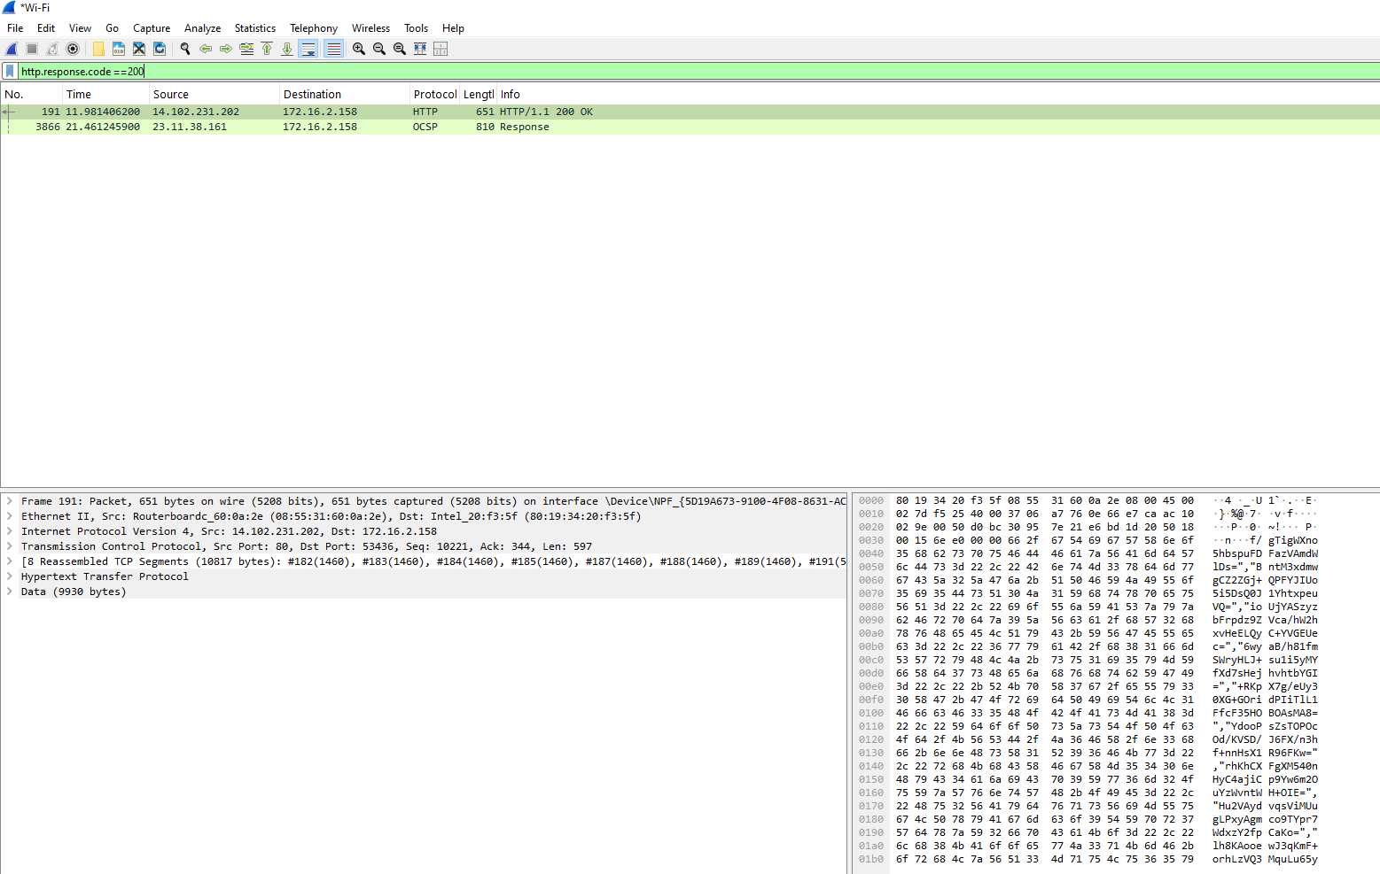

HTTP.RESPONSE.CODE ==304
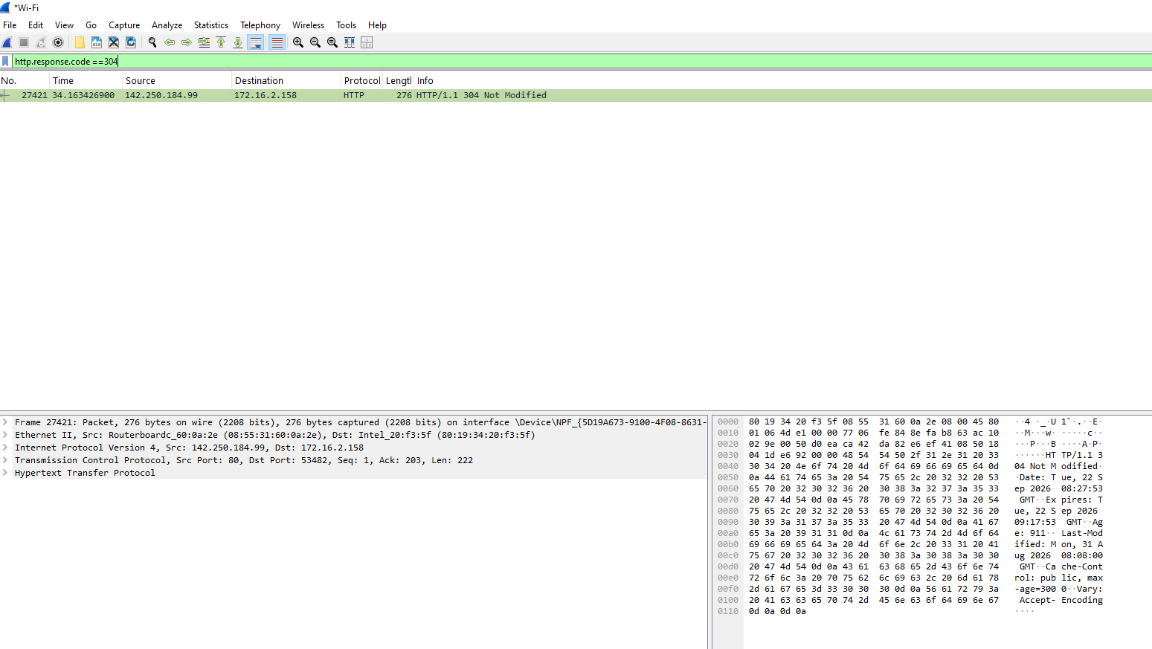

TCP.FLAGS.SYN
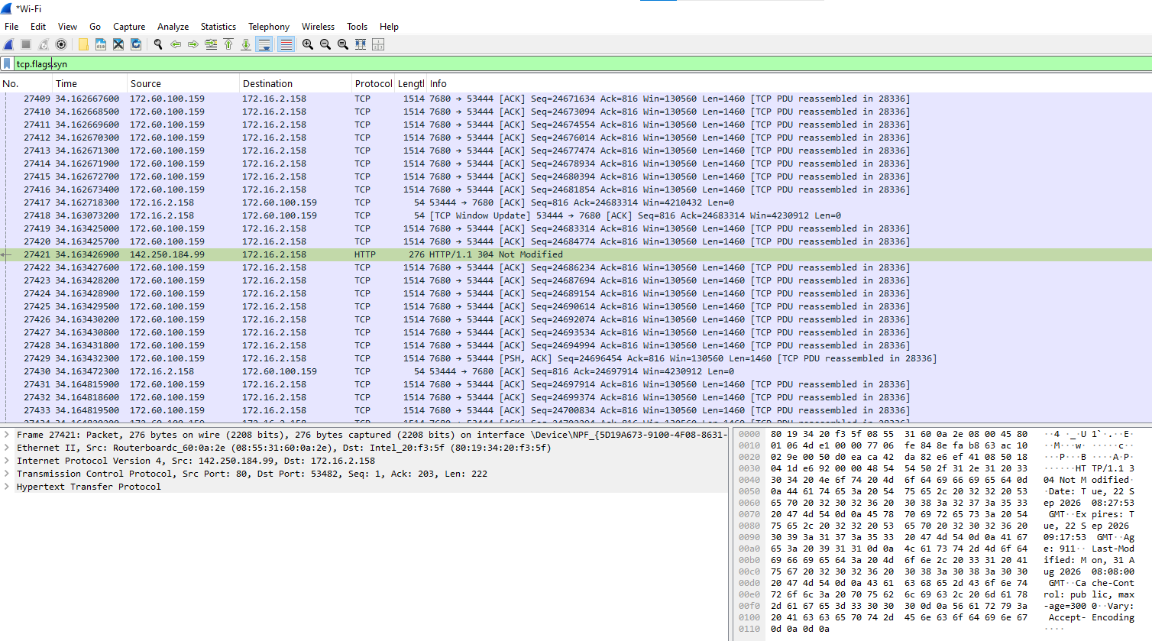
TCP.FLAGS.ACK
